Requirements and Technical
Design Specification
For
Daily NPS Backup and Retrieval
And
Market Price Uploads
Energy Transaction
Management System
[ETMS]

DOCUMENT VERSION: 1.4
DATE: May 4, 2008

Until the information within this document has been reviewed and accepted, this document may contain some conflicts of information and/or understandings between the participating parties.

Table of contents

1 INTERNAL DOCUMENT REVIEW HISTORY 3
2 ETMS BACKGROUND 4
2.1 Energy Trades Management 4
2.2 ETMS Architecture 4
2.3 Deal Entry 5
2.4 Net Position Manager 6
3 PROJECT GOALS 6
3.1 Market Prices Upload – Deal Edits – NPS Historian Flow Diagram 7
4 USER REQUIREMENT SPECIFICATIONS 8
4.1 Market Prices Upload Overview 8
4.1.1 User Requirements for Market Prices Upload 8
4.1.2 Market Prices Upload Process Diagram 9
4.2 Net Position Time Series Overview 9
4.2.1 User Requirements for NPS Historian 12
4.2.2 NPS Historical Archive Process Diagram 13
5 TECHNICAL DESIGN SPECIFICATION 14
5.1 Market Prices Upload 14
5.1.1 Create New Excel Worksheet 14
5.1.2 Deal Edits 14
5.1.3 Excel to Oracle Connectivity 15
5.1.4 Develop Upload Utilities and PL/SQL Package 15
5.2 Net Position Time Series 15
5.2.1 Dependencies 15
5.2.2 Specification 16
5.2.3 Develop NPS Archive Utilities and PL/SQL Package 16
5.2.4 Create NPS Historical Backup 16
5.3 ETMS Schema Information 17
5.3.1 Data View Lexicon 17
5.3.2 Market Prices Tables and Views 18
5.3.3 Option Schedule and Detail Views 19
5.3.4 Edit Deal Details 22
6 KEY MILESTONES AND DELIVERABLES 22
7 REPORTING REQUIREMENTS 23
8 TEAM ROLES AND RESPONSIBILITIES 23

Internal Document Review History

The following table represents the review history of this document.

Name: | Review Date: | Signature:
XXXXXXXX, Director | XXXXXXXX
XXXXXXXX, Trader | XXXXXXXX
XXXXXXXX, IS Mgr | XXXXXXXX
Baruch Braug, | XXXXXXXX

ETMS Background

Energy Trades Management

The Energy Management Team trades in Futures, SWAPs, Options, and exotic Options.

These trades represent the purchase and delivery of natural gas for our gas powered turbine power generation plants, and electric power purchases to meet our energy demands for pumping and treating water. These gas and power requirements are referred to as our “Loads”.

The monetary value of these futures, swaps, and options represent significant amounts, and must be managed under particular regulations, accounting principles, and with a traceable audit trail. The Energy Transaction Management System (ETMS) was designed to meet these and other important business requirements.

ETMS Architecture

The ETMS system was designed in the beginning stages as a “Model, View, Controller” [MVC] Java System architecture.

The ETMS architecture follows the MVC model as shown.

- RIA / XUI client (View)
- Dynamic XML generation tier (Model)
- XML data layer over Oracle 10g (Controller)

Specifically, the ETMS application topology presently is built on the following blocks.

  - The “Model” web tier presently consists of:
    - XML translator layer
    - Oracle XML Publisher
    - Oracle Databases
    - MS SQL Databases
    - MySQL Databases

  - The “View” is served via Oracle Forms based GUI client
    - Oracle Web Applet based Forms
    - XUI Menus and Forms
    - HTML Forms
    - Apache - http server
    - Tomcat – servlets container, java server

    - LZX – xml parser and formatting layer
    - oc4j – oracle forms server.

  - The “Controller” utilizes some Java system level programs for:
    - Work Flow Process Sequencing
    - On-demand Materialized Views
    - Host Programs via Java - launching with performance metrics (stored in Oracle tables).

Deal Entry

The fundamentals of a trade transaction are negotiated and “traded” by the traders.
The metadata of the “Deal” are captured in the ETMS system through deal entry web forms.

This metadata is parsed and used to generate complex flow schedules, power curves with category based pricing models, accounting records, and trade relationships to other trades.

Net Position Manager

All trades and options are aggregated real-time for value, state, and available exercises for options.

In the Market Prices Upload Excel workbook, a tab will be dedicated to displaying the current ETMS NPS materialized view data similar to graphic shown below.

<< Sensitive Data Removed >>

Click on above graphic and change zoom from 100% to 500% + to view.

Project Goals

The ETMS system will transition into the parallel test phase after the completion of the historical data management functionality is added. This historical functionality adds time series archives for the Net Position Manager aggregated data view.

The remainder of this document presents the requirements and technical design specification for the new upload, edit and historical functionality.

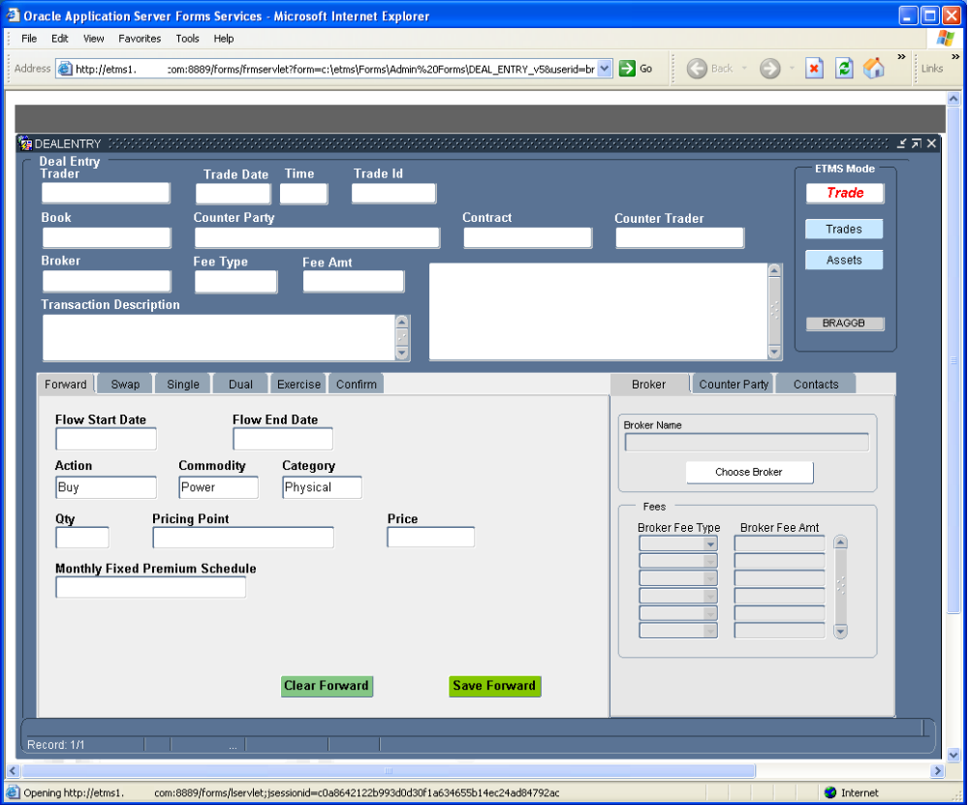
An Excel Workbook is the required client application platform. It will be created and called “Market Prices Upload - Deal Editor- NPS Historian Excel Workbook”.

The Flow Diagram below identifies the entities related and involved in this specification and is not a complete flowchart of the ETMS System.

Market Prices Upload – Deal Edits – NPS Historian Flow Diagram

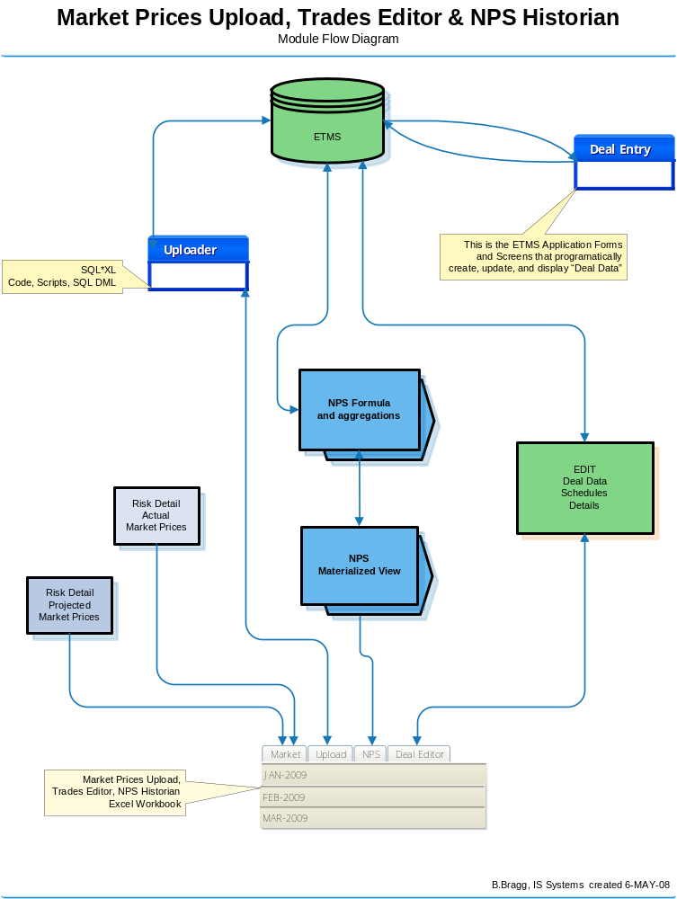

User Requirement Specifications

Market Prices Upload Overview

The market prices available in the ETMS system consist of projected prices and actual market prices.

The projected prices are calculated using risk analysis, historical price trends, etc., and are used as an estimated value that is plugged into the valuation formulas of the Net Position aggregated view. These projected prices are calculated externally in a separate process for large time frames.

The actual prices are gathered from different sources in the CSV format and then imported into Excel. There are market subscription companies that supply the price information in different data formats, and there are also several market feeds available on web pages.

The Energy Management Team utilizes both sources. These published market prices are the “actual prices”, and also need to be captured and “up-loaded” into the database price repository.

User Requirements for Market Prices Upload

The present method proposed is uploading the composed “Market Prices” data from Excel and appending onto the Oracle table etms.ETMST_RISK_DETAIL

This upload process and functionality needs to be developed and working as a prerequisite for the “Parallel Testing” phase.

Market Prices Upload Process Diagram

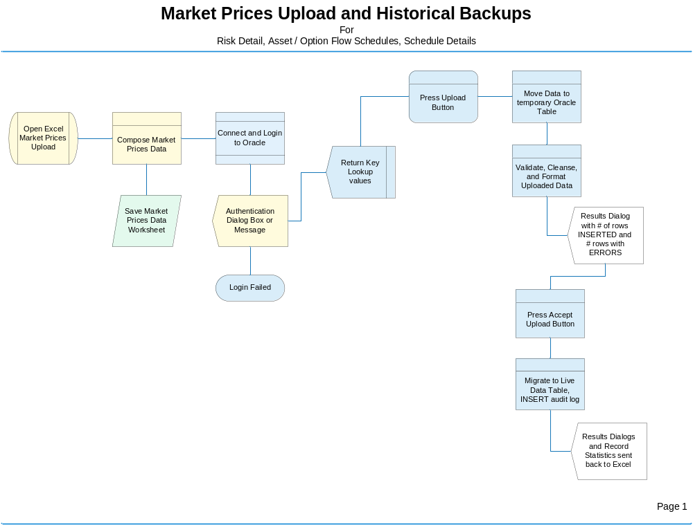

Net Position Time Series Overview

The ETMS NPS materialized view is a real-time on-demand aggregation of time sensitive data and calculations. It represents the valuation of all trade assets and trade transactions (Futures contracts, SWAPs, and Options (exercised and pending exercise)) for today and up to 10 years forward.

The ETMS NPS view is materialized though steps made available via ETMS tree menu and forms launchers.

Please note that ETMS requires Mozilla FireFox as its target browser; because Internet Explorer instance limits are exceeded due to third party software installed on trader’s workstations. The use of Mozilla FireFox is not a district standard; however, the ETMS deployment topology utilizing Firefox has been approved by XXXXXX IT Department.

The graphic shown below depicts the new ETMS Menu and subsequent windows leading to the NPS Launcher.

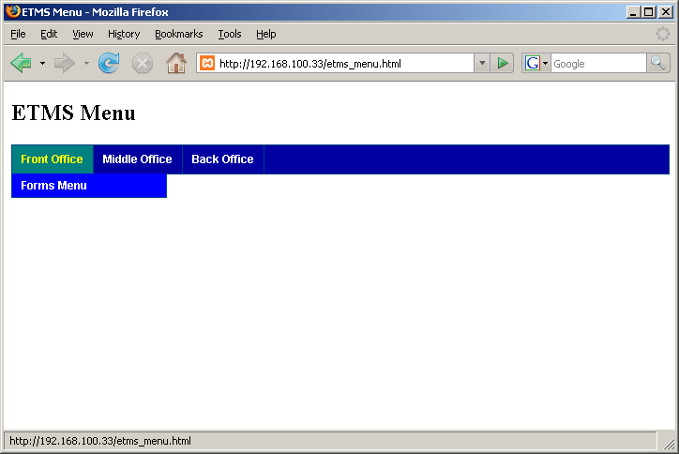

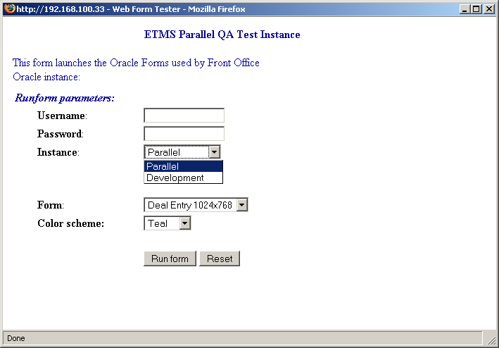

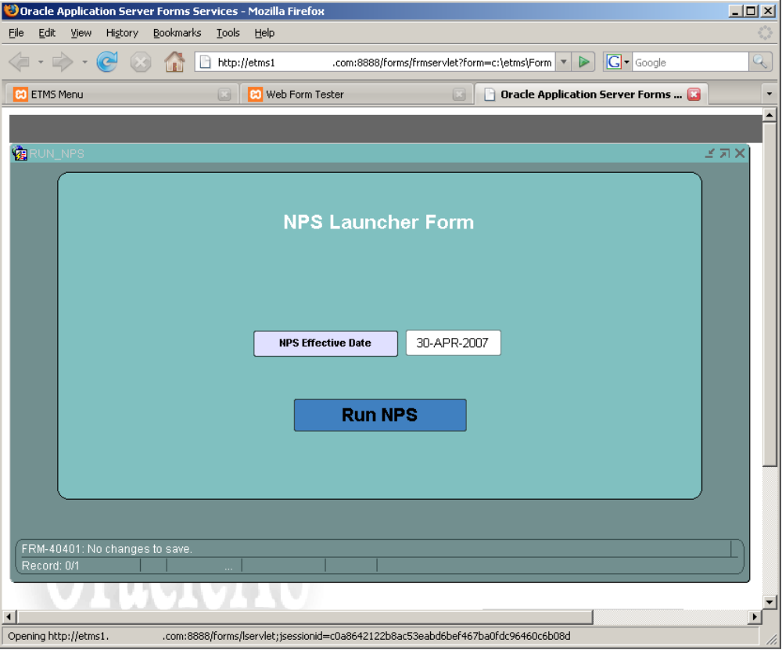

Pressing the “NPS Effective Date” button displays an Effective Date drop down box, which offers a validated list of “Market Price” effective dates currently available in the ETMS system.

Choosing a valid effective date and pressing the “Run NPS” button materializes the ETMS NPS materialized view on-demand. This produces the resultset based on current database state and data.

This on-demand process takes a few moments to run, so it is important to wait for the confirmation dialog box before refreshing Excel view or pressing the “Run NPS” button again.

The results in the ETMS NPS materialized view results can be viewed on a “Tab” ( see § 2.4) in the Market Prices Upload Excel workbook, or on the “Tab” in the Net Position Summary worksheet where it is typically queried and downloaded for viewing, comparative analysis, and what-if manipulation.

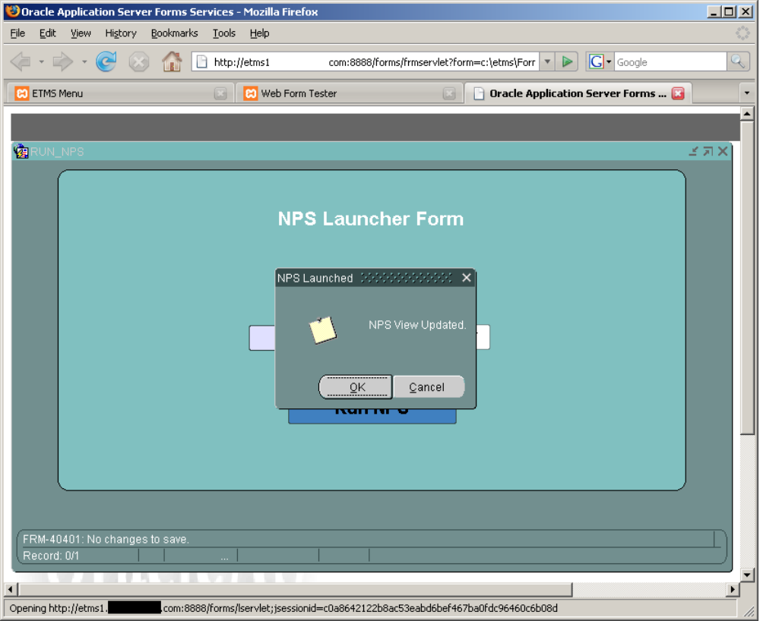

User Requirements for NPS Historian

The daily run of ETMS NPS creates a time capsule of aggregated data which must be captured into the NPS historical archive table. All time-slice data must remain in the ETMS system and made available for on-demand retrieval and queries.

The purpose of the NPS historical archive is not for real-time ETMS NPS re-creation of saved records , but as a point-of-record snapshot for that day of business. This historic data can then be queried and downloaded into an Excel worksheet such as the Energy Group’s Net Position Summary worksheet, for comparison and analysis purposes.

Launching the “Run NPS” form and choosing a valid effective date and pressing the “Run NPS” button materializes the ETMS NPS materialized view on-demand. This currently produces the resultset based on all current database states and data without discrimination for trade entry date.

The new requirement is to limit the “deal” queries feeding ETMS NPS view to be chronologically true to the chosen effective date. This means restricting “Deals” input dataset to those deals that existed in the system on that particular day of business and previous.

The effective realization of completing the items defined in this specification, and using the new tools and functionality recommended, will facilitate very flexible coverage for most or all business process scenerios discussed.

NPS Historical Archive Process Diagram

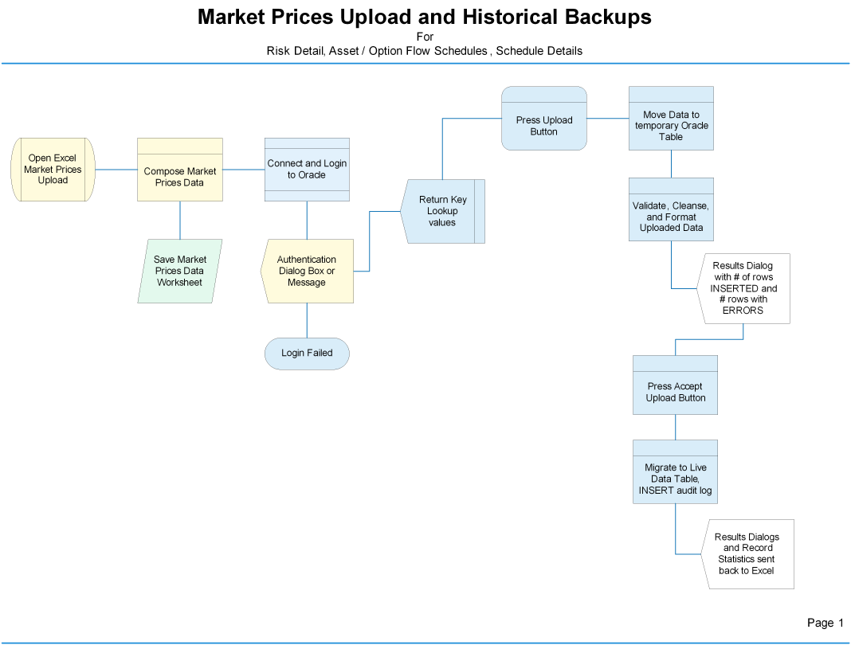

Technical Design Specification

Market Prices Upload

Create New Excel Worksheet

An Excel Workbook is the required client application platform. It will be created and called “Market Prices Upload - Deal Editor- NPS Historian Excel Workbook”.

The market prices data will be entered into a formatted Excel worksheet template to be uploaded to Oracle into the table:

etms.ETMST_RISK_DETAIL_UPLOAD

Any data conversion, cleansing, formatting, validation, etc. should be done using this table before updates into the live table etms.ETMST_RISK_DETAIL.

The worksheet will consist of data input areas that are properly mapped to the target table structures in Oracle.

This facilitates lookup lists and queries into Oracle to gather the latest data needed for key value selections and setup data values necessary to compose the market prices dataset.

Once data has been entered and validated (if any) in Excel, the rows will need a timestamp of today’s date inserted into the effective date field:

- etms.ETMST_RISK_DETAIL_UPLOAD.EFF_DATE.

This may be done within the Excel worksheet or on the Oracle server side.

The user will have a menu of options or button(s) to connect to Oracle and invoke the upload processes.

After the conversion, cleansing, formatting and validation process step, and the user responds by pushing the “Accept” button; then the dataset in etms.ETMST_RISK_DETAIL_UPLOAD table will be appended onto the etms.ETMST_RISK_DETAIL table where the live data resides.

Deal Edits

The “Deal Edits” will be handled via worksheet tabs in the Market Prices Upload Excel Workbook.

This requirement states that Deal data from ETMS (Oracle) can be queried and downloaded into Excel to accommodate non-key value edits and then uploaded back into oracle tables/views. This process will “OVERWRITE” the existing data without any undo capability from rollback.

All data integrity and constraints enforcement must be maintained; hence, the uploaded data will need to stage before migration into the live tables. The most likely point in data flow for this to be done is via tables, packages and procedures in the oracle database.

Excel to Oracle Connectivity

The Excel worksheet must have the capability of connecting to Oracle instance and execute DML, access PL/SQL utility package, functions and procedures, and then return progress and / or statistical information to the user within the session. This guarantees data integrity and a system state of health ( confidence level ) in regards to trade transactions and valuation.

Develop Upload Utilities and PL/SQL Package

This will require a new package of functions, procedures, types, etc. to be developed to support upload functionality. All data that is unique (new) and replacement of an old value with an updated value should be captured for auditing purposes in the etms.ETMST_TX_AUDIT_LOG table.

Net Position Time Series

Dependencies

The historical backup of etms.ETMS_NPS must occur each business day; however, NPS is directly dependant on any uploads or edits since it aggregates using the current live data.

The NPS dataset contains aggregations of the data within the tables and views associated with market prices, flow schedules, and trade or option details datasets; which will be managed by the “Market Prices Upload” implementation.

The main requirement in creating the NPS Historical Archive (NPS Historian) is the function of “APPENDING” the daily NPS Materialized View resultset to the newly created NPS archive table (name TBD later).

Another requirement involving the creation of NPS Historical data is that the ETMS NPS materialized view must typically run using the most “current” effective date found in the Market Prices repository (etms.ETMS_RISK_DETAIL).

In the event that a specific historical date in the past is chosen, then the query must be limited to the chronologically true records for that date and all previous deals.

Specification

The materialized NPS view output must be captured and stored in an actual table.

This is the basis of the “Historical” requirement.

This requirement states that under normal daily operating procedures an assigned person should perform the NPS archive steps manually; however, a scheduled job could be created to verify NPS daily archive completion or run it via automation.

The requirement states that there will be a stored NPS dataset appended to the NPS archive table for each business day.

These daily time-series slices of data will be used in a query or view to facilitate the browsing of NPS information for specific days of business.

This query and / or view output dataset will then be downloaded into Excel. Optionally, there may be multiple days selected for download into the Excel worksheet.

The Market Prices Upload - Deal Editor- NPS Historian Excel Worksheet should have a separate sheet(s) for NPS Historical Archive administration. This may be a form, menu options, or buttons. Using a form has the merit of sequential control. Another tab will contain the rows for returned NPS datasets, and possibly a query submitter form or area at the head of the returned rows data area.

This allows the ability to query the historical NPS data directly using ad hoc query tools.

Develop NPS Archive Utilities and PL/SQL Package

This will require a new package of functions, procedures, types, etc. to be developed to support NPS historical archive functionality. The archive dataset will be captured as part of the archive functionality and an audit journal entry for auditing purposes in the etms.ETMST_TX_AUDIT_LOG table.

Create NPS Historical Backup

The historical backup of the Net Position Summary view must occur on each business day in order to maintain a contiguous historical archive.

Along with the ability to manage the NPS Historical Backup using the above mentioned methods and requirements using manual invocation, it would be wise to have a scheduled job that would verify and run process automatically. This would ensure that all time-slice data is captured and preserved.

ETMS Schema Information

Data View Lexicon

This list represents the detailed mapping of attributes needed for API purposes

Net Position Materialized View xxxxxx.ETMS_NPS

Column Name | Oracle Datatype | NULL
EFFECTIVE_DATE | DATE | No
TRX_ID | NUMBER(10,1) | No
CONTRACT_MONTH | VARCHAR2(8 BYTE) | No
TRX_TYPE | VARCHAR2(1 BYTE) | Yes
TRX_SUB_TYPE | VARCHAR2(1 BYTE) | Yes
STRIKE_FREQ_CODE | VARCHAR2(1 BYTE) | Yes
OPT_EXP_DATE | DATE | Yes
COUNTER_LEGAL_NAME | VARCHAR2(40 BYTE) | Yes
BOOK_CODE | VARCHAR2(15 BYTE) | Yes
TRADER_NAME | VARCHAR2(40 BYTE) | Yes
FLOW_START_DATE | DATE | Yes
FLOW_END_DATE | DATE | Yes
QUANTITY | NUMBER(5,0) | Yes
PRICE_STRIKE | NUMBER | Yes
MO_FIXED_PREMIUM_AMT | NUMBER | Yes
POSTED_DATE | DATE | Yes
BROKER_FEE_TYPE | VARCHAR2(10 BYTE) | Yes
BROKER_FEE_AMT | NUMBER(10,4) | Yes
SELL_COMM | VARCHAR2(1 BYTE) | Yes
BUY_COMM | VARCHAR2(1 BYTE) | Yes
SELL_PRICE | NUMBER | Yes
BUY_PRICE | NUMBER | Yes
SELL_MULTIPLIER | NUMBER(8,4) | Yes
BUY_MULTIPLIER | NUMBER(8,4) | Yes
SELL_ADDER | NUMBER(8,4) | Yes
BUY_ADDER | NUMBER(8,4) | Yes
INT_CURVE | VARCHAR2(25 BYTE) | Yes
INT_RATE | NUMBER(6,3) | Yes
PRM_CURVE | VARCHAR2(25 BYTE) | Yes
PRICE_PREMIUM | NUMBER(16,6) | Yes
SMP_CURVE | VARCHAR2(25 BYTE) | Yes
SELL_MARKET_PRICE | NUMBER(12,6) | Yes
BMP_CURVE | VARCHAR2(25 BYTE) | Yes
BUY_MARKET_PRICE | NUMBER(12,6) | Yes
SVOL_CURVE | VARCHAR2(25 BYTE) | Yes
SELL_VOLATILITY | NUMBER(12,6) | Yes
BVOL_CURVE | VARCHAR2(25 BYTE) | Yes
BUY_VOLATILITY | NUMBER(12,6) | Yes
CORR_CURVE | VARCHAR2(25 BYTE) | Yes
CORRELATION | NUMBER(9,6) | Yes
BUY_POSITION | NUMBER | Yes
SELL_POSITION | NUMBER | Yes
SELL_DELTA | NUMBER | Yes
BUY_DELTA | NUMBER | Yes
INTRINSIC_VALUE | NUMBER | Yes
EXTRINSIC_VALUE | NUMBER | Yes
NOTL_VOLUME | NUMBER | Yes
TOTAL_VALUE | NUMBER | Yes
MTM_VALUE | NUMBER | Yes

Market Prices Tables and Views

Market Prices are housed in the ETMS_RISK_DETAIL view and consist of a MASTER-DETAIL 1: M relationship via a PK in the ETMS_RISK table/view linked to the detail data via FK to etms_risk_detail table/view.

All data uploads should be staged into a migration table for parsing, validation, comparison, transaction journaling, etc.; hence, the upload migration table for ETMS_RISK_DETAIL is ETMS_RISK_DETAIL_UPLOAD.

etms.ETMS_RISK_DETAIL_UPLOAD

Column Name | Oracle Datatype | NULL
RISK_ID | NUMBER(5,0) | No
RISK_DATE | DATE | No
RISK_VALUE | NUMBER(10,6) | No
EFF_DATE | DATE | No
INACTIVE | VARCHAR2(1 BYTE) | No
CREATED_BY | VARCHAR2(8 BYTE) | No
CREATED_DATE | DATE | No

Example data existing in etms.ETMS_RISK_DETAIL_UPLOAD and mirrored in etms.ETMS_RISK_DETAIL.

RISK_ID | RISK_DATE | RISK_VALUE | EFF_DATE | INACTIVE | CREATED_BY | CREATED_DATE
1042 | 1-Mar-09 | 60.545248 | 30-Apr-07 | N | script | 11-May-07
1042 | 1-Apr-09 | 48.177078 | 30-Apr-07 | N | script | 11-May-07
1042 | 1-May-09 | 45.110903 | 30-Apr-07 | N | script | 11-May-07
1042 | 1-Jun-09 | 49.2874 | 30-Apr-07 | N | script | 11-May-07
1042 | 1-Jul-09 | 55.182599 | 30-Apr-07 | N | script | 11-May-07
1042 | 1-Aug-09 | 58.571833 | 30-Apr-07 | N | script | 11-May-07
1042 | 1-Sep-09 | 56.883606 | 30-Apr-07 | N | script | 11-May-07
1042 | 1-Oct-09 | 53.859093 | 30-Apr-07 | N | script | 11-May-07
1042 | 1-Nov-09 | 54.393522 | 30-Apr-07 | N | script | 11-May-07
1012 | 1-Jan-07 | 33.89375 | 30-Apr-07 | N | ETMS | 16-Jan-07
1012 | 1-Feb-07 | 35.7 | 30-Apr-07 | N | ETMS | 16-Jan-07
1012 | 1-Mar-07 | 35.9125 | 30-Apr-07 | N | ETMS | 16-Jan-07
1012 | 1-Apr-07 | 30.374313 | 30-Apr-07 | N | ETMS | 16-Jan-07
1012 | 1-May-07 | 29.667384 | 30-Apr-07 | N | ETMS | 16-Jan-07
1012 | 1-Jun-07 | 33.033303 | 30-Apr-07 | N | ETMS | 16-Jan-07

etms.ETMS_RISK

Column Name | Oracle Datatype | NULL | Default
RISK_ID | NUMBER(5,0) | No | PK -> FK
RISK_NAME | VARCHAR2(25 BYTE) | No
RISK_TYPE | VARCHAR2(3 BYTE) | No
FREQ_CODE | VARCHAR2(1 BYTE) | Yes
PRJ_ACTUAL | VARCHAR2(1 BYTE) | Yes
DATA_UNITS | VARCHAR2(3 BYTE) | Yes
FREQ_FORMAT | VARCHAR2(10 BYTE) | Yes
LOAD_TYPE | VARCHAR2(2 BYTE) | Yes
INACTIVE | VARCHAR2(1 BYTE) | No
CREATED_BY | VARCHAR2(8 BYTE) | No | 'N'
CREATED_DATE | DATE | No | user
HE_GROUP_NO | VARCHAR2(3 BYTE) | Yes | sysdate

Option Schedule and Detail Views

etms.ETMS_OPTION_FLOW_SCHEDULE

Column Name | Oracle Datatype | NULL
OPTION_ID | NUMBER(10,1) | No
FLOW_DATE | DATE | No
HRS_LIGHT | NUMBER(2,0) | Yes
HRS_HEAVY | NUMBER(2,0) | Yes
HE1 | NUMBER(3,0) | Yes
HE2 | NUMBER(3,0) | Yes
HE3 | NUMBER(3,0) | Yes
HE4 | NUMBER(3,0) | Yes
HE5 | NUMBER(3,0) | Yes
HE6 | NUMBER(3,0) | Yes
HE7 | NUMBER(3,0) | Yes
HE8 | NUMBER(3,0) | Yes
HE9 | NUMBER(3,0) | Yes
HE10 | NUMBER(3,0) | Yes
HE11 | NUMBER(3,0) | Yes
HE12 | NUMBER(3,0) | Yes
HE13 | NUMBER(3,0) | Yes
HE14 | NUMBER(3,0) | Yes
HE15 | NUMBER(3,0) | Yes
HE16 | NUMBER(3,0) | Yes
HE17 | NUMBER(3,0) | Yes
HE18 | NUMBER(3,0) | Yes
HE19 | NUMBER(3,0) | Yes
HE20 | NUMBER(3,0) | Yes
HE21 | NUMBER(3,0) | Yes
HE22 | NUMBER(3,0) | Yes
HE23 | NUMBER(3,0) | Yes
HE24 | NUMBER(3,0) | Yes
INACTIVE | VARCHAR2(1 BYTE) | No
CREATED_BY | VARCHAR2(8 BYTE) | No
CREATED_DATE | DATE | No

etms.ETMS_ASSET_FLOW_SCHEDULE

Column Name | Oracle Datatype | NULL
ASSET_ID | NUMBER(10,1) | No
FLOW_DATE | DATE | No
HRS_LIGHT | NUMBER(2,0) | Yes
HRS_HEAVY | NUMBER(2,0) | Yes
HE1 | NUMBER(3,0) | Yes
HE2 | NUMBER(3,0) | Yes
HE3 | NUMBER(3,0) | Yes
HE4 | NUMBER(3,0) | Yes
HE5 | NUMBER(3,0) | Yes
HE6 | NUMBER(3,0) | Yes
HE7 | NUMBER(3,0) | Yes
HE8 | NUMBER(3,0) | Yes
HE9 | NUMBER(3,0) | Yes
HE10 | NUMBER(3,0) | Yes
HE11 | NUMBER(3,0) | Yes
HE12 | NUMBER(3,0) | Yes
HE13 | NUMBER(3,0) | Yes
HE14 | NUMBER(3,0) | Yes
HE15 | NUMBER(3,0) | Yes
HE16 | NUMBER(3,0) | Yes
HE17 | NUMBER(3,0) | Yes
HE18 | NUMBER(3,0) | Yes
HE19 | NUMBER(3,0) | Yes
HE20 | NUMBER(3,0) | Yes
HE21 | NUMBER(3,0) | Yes
HE22 | NUMBER(3,0) | Yes
HE23 | NUMBER(3,0) | Yes
HE24 | NUMBER(3,0) | Yes
INACTIVE | VARCHAR2(1 BYTE) | No
CREATED_BY | VARCHAR2(8 BYTE) | No
CREATED_DATE | DATE | No

etms.ETMS_OPTION_SCHED_DETAIL

Column Name | Oracle Datatype | NULL
OPTION_SCHED_ID | NUMBER(5,0) | No
OPTION_ID | NUMBER(10,1) | No
OPTION_SCHED_LINE_NO | NUMBER | No
OPTION_EXP_DATE | DATE | No
NOTICE_DATE | DATE | No
OPTION_EXR_DATE | DATE | Yes
TRADE_ID | NUMBER(10,1) | Yes
PRICE_MULTIPLIER | NUMBER(16,4) | Yes
PRICE_ADDER | NUMBER(16,4) | Yes
QUANTITY | NUMBER(5,0) | Yes
PRICE_PREMIUM | NUMBER(16,4) | Yes
MO_FIXED_PREMIUM_AMT | NUMBER(10,4) | Yes
AVAIL_MULTIPLIER | NUMBER(16,4) | Yes
STANDARD_FLAG | VARCHAR2(1 BYTE) | Yes
INACTIVE | VARCHAR2(1 BYTE) | No
CREATED_BY | VARCHAR2(8 BYTE) | No
CREATED_DATE | DATE | No
ACTION_MONTH | VARCHAR2(8 BYTE) | Yes
ACTION_DAY | VARCHAR2(11 BYTE) | Yes

etms.ETMS_ASSET_SCHED_DETAIL

Column Name | Oracle Datatype | NULL
ASSET_SCHED_ID | NUMBER(5,0) | No
ASSET_ID | NUMBER(10,1) | No
ASSET_SCHED_LINE_NO | NUMBER | No
ASSET_EXP_DATE | DATE | No
NOTICE_DATE | DATE | Yes
ASSET_EXR_DATE | DATE | Yes
TRADE_ID | NUMBER(10,1) | Yes
PRICE_MULTIPLIER | NUMBER(16,4) | Yes
PRICE_ADDER | NUMBER(16,4) | Yes
QUANTITY | NUMBER(5,0) | Yes
PRICE_PREMIUM | NUMBER(16,4) | Yes
MO_FIXED_PREMIUM_AMT | NUMBER(10,4) | Yes
AVAIL_MULTIPLIER | NUMBER(16,4) | Yes
STANDARD_FLAG | VARCHAR2(1 BYTE) | Yes
INACTIVE | VARCHAR2(1 BYTE) | No
CREATED_BY | VARCHAR2(8 BYTE) | No
CREATED_DATE | DATE | No
ACTION_MONTH | VARCHAR2(8 BYTE) | Yes
ACTION_DAY | VARCHAR2(11 BYTE) | Yes

Edit Deal Details

There is a requirement to edit certain non-key “Deal” data in the ETMS_XXXX_FLOW_SCHEDULE and ETMS_XXXX_SCHED_DETAIL tables. The tables involved are the:

- ETMS_TRADE_FLOW_SCHEDULE
- ETMS_TRADE_SCHED_DETAIL
- ETMS_OPTION_FLOW_SCHEDULE
- ETMS_OPTION_SCHED_DETAIL
- ETMS_ASSET_FLOW_SCHEDULE
- ETMS_ASSET_SCHED_DETAIL

The fields that have been discussed to date that need edit capability are:

- Quantity
- Price_premium
- Mo_fixed_premium_amt

Any changes to the data require that a transaction journaling utility be used (written) that can handle the events of insert and updates of the replaced data values, and store journal items in the ETMS_TX_AUDIT_LOG table.

There is a trade regeneration utility that is capable of regenerating trade based on the primary metadata. This utility does not support preserving post-generation edits and updates. The net position summary (materialized view) aggregates data and calculations from whatever data exists in the tables; along with the current edits and updates; which will be reflected in the NPS view output.

Changes to “Quantity” must be propagated in both the ETMS_XXXX_FLOW_SCHEDULE tables as well as the ETMS_XXXX_SCHED_DETAIL tables, but not to the metadata table or view: etms.etms_trade

Key Milestones and Deliverables

The key milestones, deliverables and responsibilities are:

Deliverable Item | Responsibility
Requirements and Technical Spec For Market Prices Upload and NPS Backup | IS Team
Market Price Up-Loader | ---
Historical Time-Series Capture Functionality | ---
Time-Series Query components and add-ins | ---
Excel Export capabilities | ---
Option Detail Data Editing | ---
Trade Regeneration  (follows any detail data edits to re-sync system) | ---

Reporting Requirements

Pre-defined and ad-hoc queries and reports (if any) are accomplished via data source connectivity to Oracle; using such tools like Excel. There is a requirement in other ETMS Requirement documents to have a mechanism that can generate/export into formats such as MS Word or Excel.

Team Roles and Responsibilities

Below are the roles and responsibilities for each piece of the project…

Energy Management Team: | Responsibility
xxxxxxxxxxxx | Director, Energy Management, Project Executive
xxxxxxxxxxxx

IS Development Team: | Responsibility
xxxxxxxxxx | IS Supervisor, Project Advisor
Bruce Bragg | Project Technical Lead and Advisor

